1-Streaming Protocols

🎬 What Are Streaming Protocols?
# Source: AI Source: Provided by: [Data Path: Persons Table -> ID Column: 1, Name_En Column: Motasem Essam] -> From: [ChatGPT] on [1/18/2026]
Streaming protocols control how audio/video is delivered over the internet in small pieces so users can watch it in real time — even while it’s still downloading.
📦 Instead of sending one huge file, they deliver chunks of video, usually a few seconds long.

🔧 The 2 Most Common Streaming Protocols:
# Source: AI Source: Provided by: [Data Path: Persons Table -> ID Column: 1, Name_En Column: Motasem Essam] -> From: [ChatGPT] on [1/18/2026]
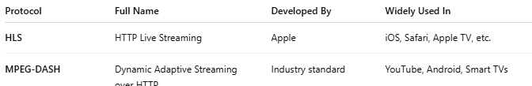
Protocol | Full Name | Developed By | Widely Used In
HLS | HTTP Live Streaming | Apple | iOS, Safari, Apple TV, etc.
MPEG-DASH | Dynamic Adaptive Streaming over HTTP | Industry standard | YouTube, Android, Smart TVs

🧠 How HLS / DASH Work (Step-by-Step)

1. Video is encoded
# Source: AI Source: Provided by: [Data Path: Persons Table -> ID Column: 1, Name_En Column: Motasem Essam] -> From: [ChatGPT] on [1/18/2026]
🎞️ The original video is compressed into different resolutions and bitrates (e.g. 1080p, 720p, 480p) using a video encoder.

2. Video is split into chunks
# Source: AI Source: Provided by: [Data Path: Persons Table -> ID Column: 1, Name_En Column: Motasem Essam] -> From: [ChatGPT] on [1/18/2026]
✂️ Each resolution is split into small segments — usually 2 to 10 seconds long.
- e.g. segment1.ts, segment2.ts, segment3.ts (for HLS)
- e.g. chunk_1.m4s, chunk_2.m4s (for DASH)

3. Playlist is created
# Source: AI Source: Provided by: [Data Path: Persons Table -> ID Column: 1, Name_En Column: Motasem Essam] -> From: [ChatGPT] on [1/18/2026]
📄 A text file (called a manifest or playlist) is generated:
- HLS: .m3u8 playlist
- DASH: .mpd (Media Presentation Description)
This file lists:
- Available video qualities
- URLs of each video segment
- Timing and duration

4. Client (browser/app) downloads manifest
# Source: AI Source: Provided by: [Data Path: Persons Table -> ID Column: 1, Name_En Column: Motasem Essam] -> From: [ChatGPT] on [1/18/2026]
🧠 When you hit "play," your device first fetches the manifest file, then selects a video quality based on your internet speed.

5. Streaming begins
# Source: AI Source: Provided by: [Data Path: Persons Table -> ID Column: 1, Name_En Column: Motasem Essam] -> From: [ChatGPT] on [1/18/2026]
📶 The client begins downloading the first few chunks and starts playing immediately — while continuing to buffer more chunks in the background.

6. Adaptive Bitrate Streaming (ABR)
# Source: AI Source: Provided by: [Data Path: Persons Table -> ID Column: 1, Name_En Column: Motasem Essam] -> From: [ChatGPT] on [1/18/2026]
📉📈 If your internet slows down, the player automatically switches to lower quality video (e.g. 1080p → 720p → 480p), without stopping playback.
This ensures:
- ✅ Smooth playback
- ✅ Minimal buffering
- ✅ Mobile-friendly bandwidth use

📊 Visual Diagram
# Source: AI Source: Provided by: [Data Path: Persons Table -> ID Column: 1, Name_En Column: Motasem Essam] -> From: [ChatGPT] on [1/18/2026]
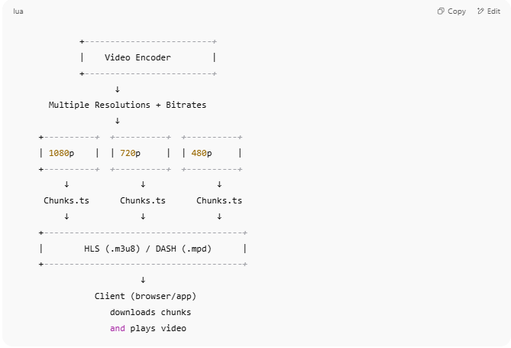
+-------------------------+
| Video Encoder |
+-------------------------+
↓
Multiple Resolutions + Bitrates
↓
+----------+ +----------+ +----------+
| 1080p | | 720p | | 480p |
+----------+ +----------+ +----------+
↓ ↓ ↓
Chunks.ts Chunks.ts Chunks.ts
↓ ↓ ↓
+---------------------------------------+
| HLS (.m3u8) / DASH (.mpd) |
+---------------------------------------+
↓
Client (browser/app)
downloads chunks
and plays video

✅ Summary Table
# Source: AI Source: Provided by: [Data Path: Persons Table -> ID Column: 1, Name_En Column: Motasem Essam] -> From: [ChatGPT] on [1/18/2026]
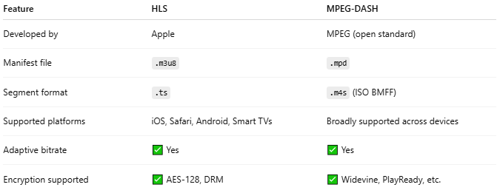
Feature | HLS | MPEG-DASH
Developed by | Apple | MPEG (open standard)
Manifest file | .m3u8 | .mpd
Segment format | .ts | .m4s (ISO BMFF)
Supported platforms | iOS, Safari, Android, Smart TVs | Broadly supported across devices
Adaptive bitrate | ✅ Yes | ✅ Yes
Encryption supported | ✅ AES-128, DRM | ✅ Widevine, PlayReady, etc.

2-HLS

📺 What is HLS (HTTP Live Streaming)?
# Source: AI Source: Provided by: [Data Path: Persons Table -> ID Column: 1, Name_En Column: Motasem Essam] -> From: [ChatGPT] on [1/18/2026]
HLS stands for HTTP Live Streaming.
It is a streaming media protocol developed by Apple to deliver video and audio content over the internet in real-time — like when you watch videos on Safari, iOS apps, or Apple TV.
📌 HLS breaks videos into small segments (chunks) and delivers them over regular HTTP. It allows the video to play while it's still downloading, making it ideal for live and on-demand streaming.

🧠 Key Features of HLS
# Source: AI Source: Provided by: [Data Path: Persons Table -> ID Column: 1, Name_En Column: Motasem Essam] -> From: [ChatGPT] on [1/18/2026]
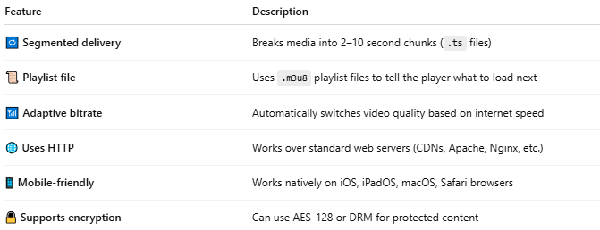
Feature | Description
🔁 Segmented delivery | Breaks media into 2–10 second chunks (.ts files)
📜 Playlist file | Uses .m3u8 playlist files to tell the player what to load next
📶 Adaptive bitrate | Automatically switches video quality based on internet speed
🌐 Uses HTTP | Works over standard web servers (CDNs, Apache, Nginx, etc.)
📱 Mobile-friendly | Works natively on iOS, iPadOS, macOS, Safari browsers
🔒 Supports encryption | Can use AES-128 or DRM for protected content

🔄 How HLS Works (Simplified)
# Source: AI Source: Provided by: [Data Path: Persons Table -> ID Column: 1, Name_En Column: Motasem Essam] -> From: [ChatGPT] on [1/18/2026]
- 🎞️ Video is encoded at multiple resolutions (e.g. 1080p, 720p, 480p).
- ✂️ Each resolution is split into chunks (2–10 seconds long).
- 📄 An .m3u8 file (playlist) is created listing the chunks and qualities.
- 🌍 The user's browser or app downloads the playlist and plays the chunks.
- ⚖️ HLS adjusts the video quality on the fly (adaptive streaming).

📦 File Structure Example
# Source: AI Source: Provided by: [Data Path: Persons Table -> ID Column: 1, Name_En Column: Motasem Essam] -> From: [ChatGPT] on [1/18/2026]

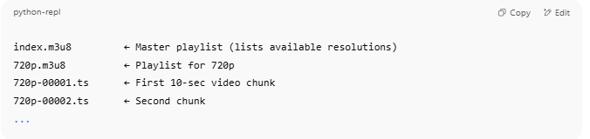
index.m3u8 ← Master playlist (lists available resolutions)
720p.m3u8 ← Playlist for 720p
720p-00001.ts ← First 10-sec video chunk
720p-00002.ts ← Second chunk
...

📱 HLS Is Used In:
# Source: AI Source: Provided by: [Data Path: Persons Table -> ID Column: 1, Name_En Column: Motasem Essam] -> From: [ChatGPT] on [1/18/2026]
- Apple devices (iPhone, iPad, Safari)
- Streaming services (Twitch, Vimeo, live events)
- Mobile-friendly websites
- Live news broadcasts
- Educational video platforms

✅ Advantages of HLS
# Source: AI Source: Provided by: [Data Path: Persons Table -> ID Column: 1, Name_En Column: Motasem Essam] -> From: [ChatGPT] on [1/18/2026]
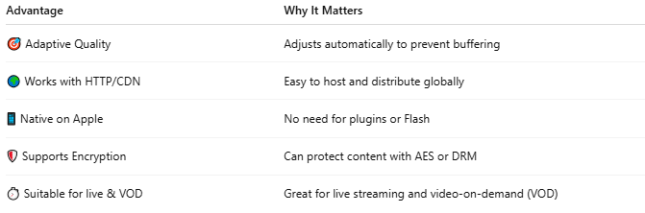
Advantage | Why It Matters
🎯 Adaptive Quality | Adjusts automatically to prevent buffering
🌍 Works with HTTP/CDN | Easy to host and distribute globally
📱 Native on Apple | No need for plugins or Flash
🛡️ Supports Encryption | Can protect content with AES or DRM
⏱️ Suitable for live & VOD | Great for live streaming and video-on-demand (VOD)

🚫 Limitations
# Source: AI Source: Provided by: [Data Path: Persons Table -> ID Column: 1, Name_En Column: Motasem Essam] -> From: [ChatGPT] on [1/18/2026]
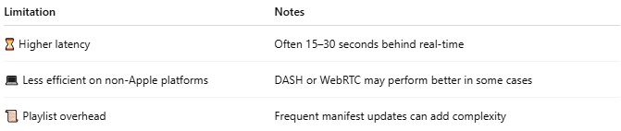
Limitation | Notes
⏳ Higher latency | Often 15–30 seconds behind real-time
💻 Less efficient on non-Apple platforms | DASH or WebRTC may perform better in some cases
📜 Playlist overhead | Frequent manifest updates can add complexity

✅ Summary
# Source: AI Source: Provided by: [Data Path: Persons Table -> ID Column: 1, Name_En Column: Motasem Essam] -> From: [ChatGPT] on [1/18/2026]
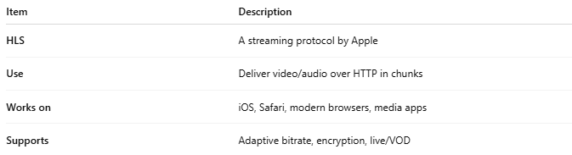
Item | Description
HLS | A streaming protocol by Apple
Use | Deliver video/audio over HTTP in chunks
Works on | iOS, Safari, modern browsers, media apps
Supports | Adaptive bitrate, encryption, live/VOD

3-DASH

📺 What is DASH (MPEG-DASH)?
# Source: AI Source: Provided by: [Data Path: Persons Table -> ID Column: 1, Name_En Column: Motasem Essam] -> From: [ChatGPT] on [1/18/2026]
DASH stands for Dynamic Adaptive Streaming over HTTP.
It is a streaming protocol standard developed by the MPEG group (not by a single company) to deliver high-quality video/audio over the internet in an adaptive and efficient way.
📌 Like HLS, DASH streams media in small chunks and adjusts quality based on the viewer’s network speed — but it’s an open standard and not limited to Apple platforms.

🧠 Key Features of MPEG-DASH
# Source: AI Source: Provided by: [Data Path: Persons Table -> ID Column: 1, Name_En Column: Motasem Essam] -> From: [ChatGPT] on [1/18/2026]
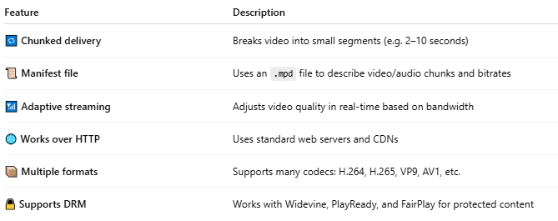
Feature | Description
🔁 Chunked delivery | Breaks video into small segments (e.g. 2–10 seconds)
📜 Manifest file | Uses an .mpd file to describe video/audio chunks and bitrates
📶 Adaptive streaming | Adjusts video quality in real-time based on bandwidth
🌐 Works over HTTP | Uses standard web servers and CDNs
📦 Multiple formats | Supports many codecs: H.264, H.265, VP9, AV1, etc.
🔒 Supports DRM | Works with Widevine, PlayReady, and FairPlay for protected content

🔧 How DASH Works (Simplified)
# Source: AI Source: Provided by: [Data Path: Persons Table -> ID Column: 1, Name_En Column: Motasem Essam] -> From: [ChatGPT] on [1/18/2026]
- 🎞️ Your video is encoded into multiple qualities (e.g. 1080p, 720p).
- ✂️ Each quality is split into small chunks (.m4s files).
- 📄 An .mpd manifest file is created listing available resolutions and chunk URLs.
- 🌍 The browser or app fetches the manifest and streams the chunks.
- ⚖️ Quality changes automatically depending on internet speed (ABR).

📁 File Structure Example
# Source: AI Source: Provided by: [Data Path: Persons Table -> ID Column: 1, Name_En Column: Motasem Essam] -> From: [ChatGPT] on [1/18/2026]

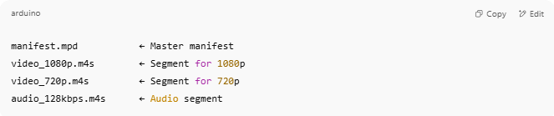
manifest.mpd ← Master manifest
video_1080p.m4s ← Segment for 1080p
video_720p.m4s ← Segment for 720p
audio_128kbps.m4s ← Audio segment

✅ DASH vs HLS
# Source: AI Source: Provided by: [Data Path: Persons Table -> ID Column: 1, Name_En Column: Motasem Essam] -> From: [ChatGPT] on [1/18/2026]
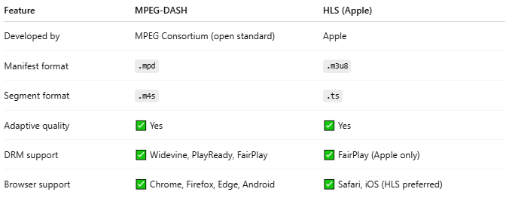
Feature | MPEG-DASH | HLS (Apple)
Developed by | MPEG Consortium (open standard) | Apple
Manifest format | .mpd | .m3u8
Segment format | .m4s | .ts
Adaptive quality | ✅ Yes | ✅ Yes
DRM support | ✅ Widevine, PlayReady, FairPlay | ✅ FairPlay (Apple only)
Browser support | ✅ Chrome, Firefox, Edge, Android | ✅ Safari, iOS (HLS preferred)

🧪 Where is DASH Used?
# Source: AI Source: Provided by: [Data Path: Persons Table -> ID Column: 1, Name_En Column: Motasem Essam] -> From: [ChatGPT] on [1/18/2026]
- YouTube (on non-Apple browsers)
- Netflix (in many TV apps and Android)
- Vimeo, Twitch, Facebook Live
- Educational & enterprise platforms
- Smart TVs & Android media apps

✅ Summary
# Source: AI Source: Provided by: [Data Path: Persons Table -> ID Column: 1, Name_En Column: Motasem Essam] -> From: [ChatGPT] on [1/18/2026]

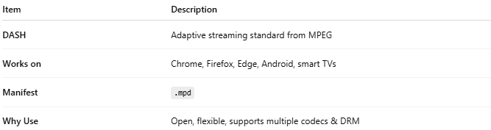
Item | Description
DASH | Adaptive streaming standard from MPEG
Works on | Chrome, Firefox, Edge, Android, smart TVs
Manifest | .mpd
Why Use | Open, flexible, supports multiple codecs & DRM

3-RTMP

📡 What is RTMP?
# Source: AI Source: Provided by: [Data Path: Persons Table -> ID Column: 1, Name_En Column: Motasem Essam] -> From: [ChatGPT] on [1/18/2026]
RTMP stands for Real-Time Messaging Protocol.
It’s a streaming protocol originally developed by Macromedia (later Adobe) for delivering live video, audio, and data over the internet, primarily used with Flash.
🔴 Today, RTMP is mostly used to upload (ingest) live streams from tools like OBS to platforms like YouTube, Facebook Live, or Twitch — even though playback now uses HLS or DASH.

🧠 How RTMP Works
# Source: AI Source: Provided by: [Data Path: Persons Table -> ID Column: 1, Name_En Column: Motasem Essam] -> From: [ChatGPT] on [1/18/2026]
RTMP creates a persistent connection between a broadcaster (like OBS) and a media server (like Nginx, Wowza, or YouTube's live endpoint).
It sends media in chunks with low latency (almost real-time).

🧪 Typical RTMP Workflow:
# Source: AI Source: Provided by: [Data Path: Persons Table -> ID Column: 1, Name_En Column: Motasem Essam] -> From: [ChatGPT] on [1/18/2026]

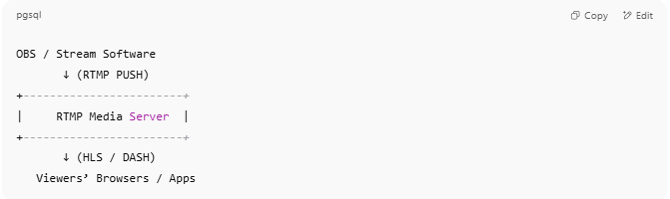

OBS / Stream Software
↓ (RTMP PUSH)
+------------------------+
| RTMP Media Server |
+------------------------+
↓ (HLS / DASH)
Viewers’ Browsers / Apps

- 🎥 OBS captures webcam/mic and streams to server via RTMP
- 🌍 Server converts RTMP → HLS or DASH
- 📱 Viewers watch using standard HTML5 video players

🎯 RTMP URL Example
# Source: AI Source: Provided by: [Data Path: Persons Table -> ID Column: 1, Name_En Column: Motasem Essam] -> From: [ChatGPT] on [1/18/2026]

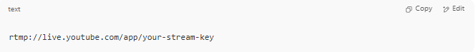
rtmp://live.youtube.com/app/your-stream-key

This is what you'd paste into OBS to stream to YouTube Live.

✅ RTMP Features
# Source: AI Source: Provided by: [Data Path: Persons Table -> ID Column: 1, Name_En Column: Motasem Essam] -> From: [ChatGPT] on [1/18/2026]
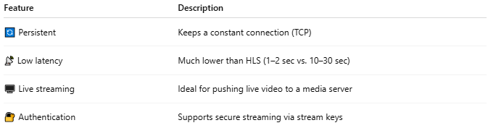

Feature | Description
🔄 Persistent | Keeps a constant connection (TCP)
📡 Low latency | Much lower than HLS (1–2 sec vs. 10–30 sec)
🖥️ Live streaming | Ideal for pushing live video to a media server
🔐 Authentication | Supports secure streaming via stream keys

📉 Why RTMP is Less Used for Playback Now
# Source: AI Source: Provided by: [Data Path: Persons Table -> ID Column: 1, Name_En Column: Motasem Essam] -> From: [ChatGPT] on [1/18/2026]
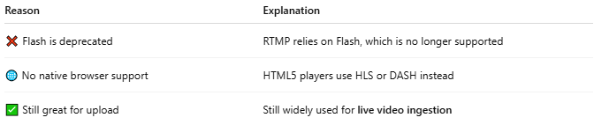

Reason | Explanation
❌ Flash is deprecated | RTMP relies on Flash, which is no longer supported
🌐 No native browser support | HTML5 players use HLS or DASH instead
✅ Still great for upload | Still widely used for live video ingestion

✅ Summary
# Source: AI Source: Provided by: [Data Path: Persons Table -> ID Column: 1, Name_En Column: Motasem Essam] -> From: [ChatGPT] on [1/18/2026]

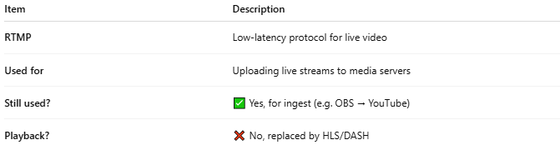
Item | Description
RTMP | Low-latency protocol for live video
Used for | Uploading live streams to media servers
Still used? | ✅ Yes, for ingest (e.g. OBS → YouTube)
Playback? | ❌ No, replaced by HLS/DASH

Would you like:
- A real RTMP test server to try streaming with OBS?
- Or to set up your own local RTMP server using Nginx?

